AI-powered resume analysis engine: <https://resumeworded.com/results-v2>

<https://www.jobscan.co/>

What to write in the CV

4-5 relevant sections

-Resume Summary (More on this later)

-Work-Ex

-Education

-Internships

-Achievements

-Projects

-Extra-Curriculars

-Anything else that makes u stand out

How to write about your workex:

- Use Action words like Directed/Managed/Spearheaded instead of Duties included

- Convey stories - What was the Problem ? What actions you took? What were the results? What skills did you use & develop?

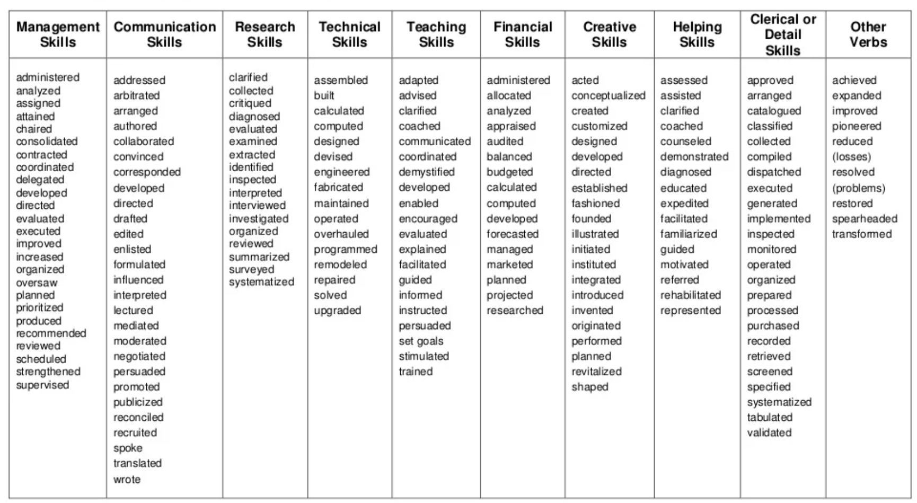

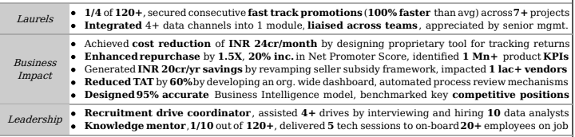

Very IMPORTANT to get shortlisted:

- More than 90% companies now use software (called ATS) to shortlist

- Software checks keywords to match job description (JD)

- Hence, you need TO include relevant keywords in your CV and tailor each CV based on the specific job

Resume Summary:

- Not required for freshers

- Not more than 3 sentences.

- Mention experience, top achievements

- What type of role you are looking at

- Helps in computerized shortlisting if you include relevant keywords

Dos:

- Send file as firstname_lastname, not as cv/resume

- Send pdf file and not as a word file

- Include action words from Job Description

- Choose a neat template

- Fit most points in 1 line

- Length: 1 page for work-ex < 10 yrs, 2 pages max

Donts:

-Don’t make bold claims that cannot be backed up

-Don’t just list job duties; focus on accomplishments

-Avoid personal pronouns (I/me/my)

-Unprofessional email ID like coolguy352

-No need for Photo/DOB

-Don't bold too many words

Common Mistakes:

-Typos/ grammatical errors

-More than 2 lines on any point

- Inconsistent font size/line spacing

- Being unethical like disclosing confidential info

- Verbose resume with length > 2 pages

Technical aspects

-Select a professional font eg Arial/ Calibri/Garamond

- Readable size (10.5-12) for text

- Leave ample white-space so that it is soothing to read

- 1/2-1 inch margins on all sides

- Single spacing works best

For example following is the Job summary for ML Engineer and Data Scientist:

* Strong understanding of Azure environment (PaaS, IaaS) and experience in working with hybrid model.
* Ability to guide and instruct mid-size team of Azure Data Engineers.
* Understand and design/reverse engineering AWS DataSync ETL codes, implement the same data solutions through Azure services.
* Design and build simple to complex ETLs in Azure Data Factory, Synapse Spark Notebooks and Azure DataBricks.
* Should be able to design modules that has security and authorization frameworks.
* Analyze current business practices, processes and procedures and identify future opportunities for leveraging Azure data & analytics PaaS services.
* Minimum 5-10 years of ETL experience using Azure data services
* Analyse and process large sets of structured and unstructured data.
* Optimize machine learning algorithms for performance and scalability.
* Partner with cross functional stakeholders to define a long-term vision for scaling ML/AI applications in production and help teams with their roadmap plannings.
* Provide technical mentorship to Junior Engineers and act as a technical leader for the ML engineering domain.
* Modernize foundational applications
* Prioritize and deploy AI/ML capabilities (enable self-service NLP for document management tool, "Darcy")
* Develop MDM strategy centered on data quality
* Enhance reporting capabilities to support clinical trial growth (ELT vs ETL)
* Data Engineering and Data Modeling skills
* Experience with Extract Transform Load (ETL) pipelines
* Expertise in implementing data warehousing solutions
* Analytical skills for performing data analytics on large datasets
* Strong programming skills in languages like Python, Java, or Scala
* Experience with Big Data and cloud-based technologies like Hadoop, Spark, and AWS
* Understanding of data governance and security principles
* Bachelor's degree in Computer Science, Information Systems, or related field
* Strong communication skills and ability to work independently and collaboratively

